$1 OFF Any order $8 Or more  How  Like Us On Facebook  Where  www.Facebook.com/my-business-url  Or Scan This QR Code With Your Smartphone:  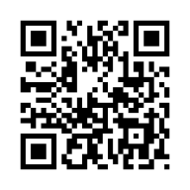 |  |  | How It Works  Show us  Once You Like The Page Just Show Us Your Smart Phone  What Else?  Write Us A Review on YELP or Google and Get A 50% Coupon for Your Next Visit  Follow US  Instagram  Twitter  Foursqaure  Search:  #yourbusinessname  More  Join Our Exclusive Newsletter at www.website.com/  newsletter

